Name: Adilah binti Adi Yasran

Matric: 198989

JSP Practical

JSP pages are used to develop dynamic responses. In java code, we create the JSP file using the scriplet tag which start with </ and ends with />. In this lab practice, we need to implement the JSP file for login page, add new student and average marks for math, science and English subject that is extended from previous lab.

Outputs

Login Page (index.html)

The user need to input their student ID and password to access the system. Only the authorized user can access it which is their id and password are already stored in database.

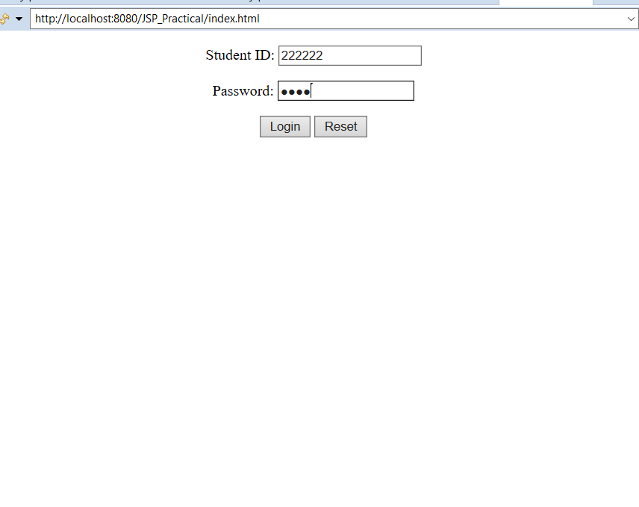

New student page (addStudent.html)

The new student added with their id, password, name and department to store in database.

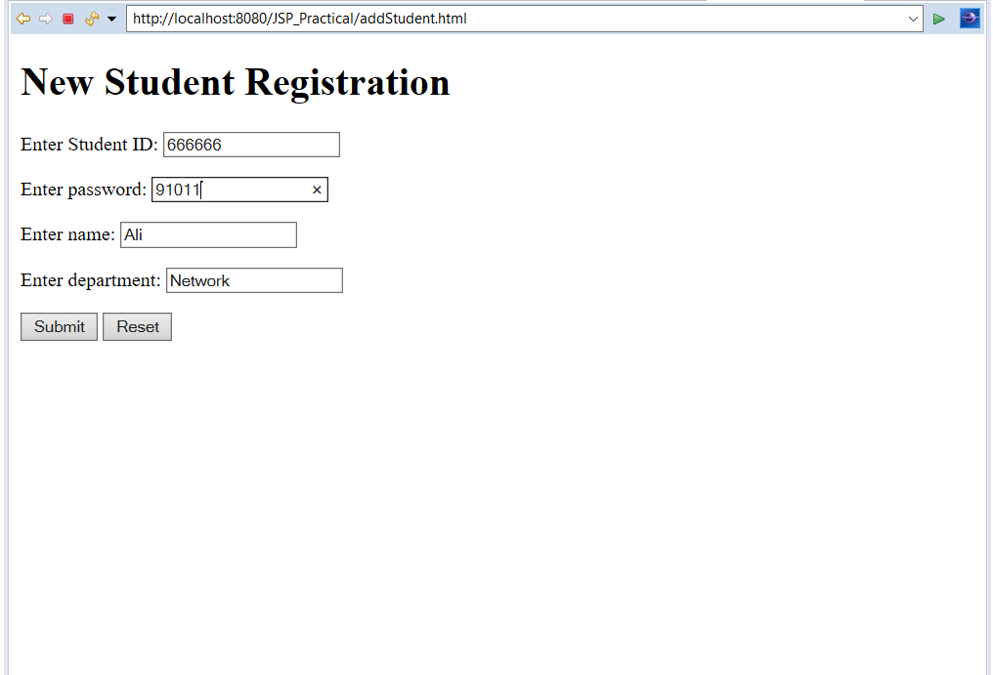

Student Info Page (studentInfo.jsp)

In this page, the information of all the students are displayed with their ID, name and department.

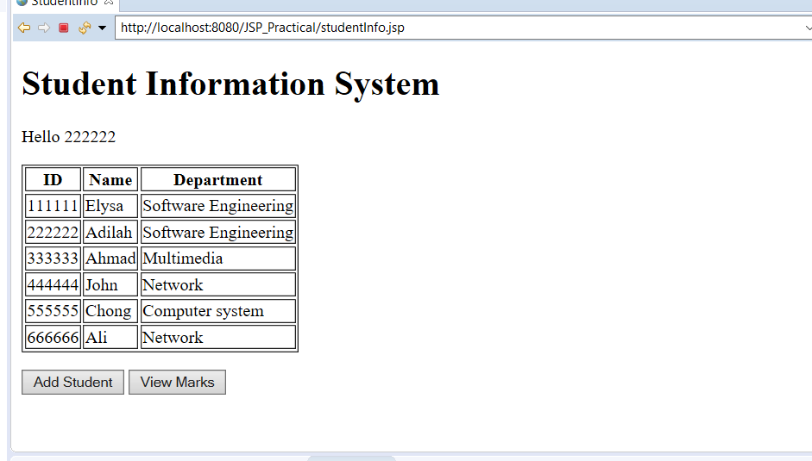

Add student’s mark page (addMark.html)

This page allows user to add the marks for science, math and English subject.

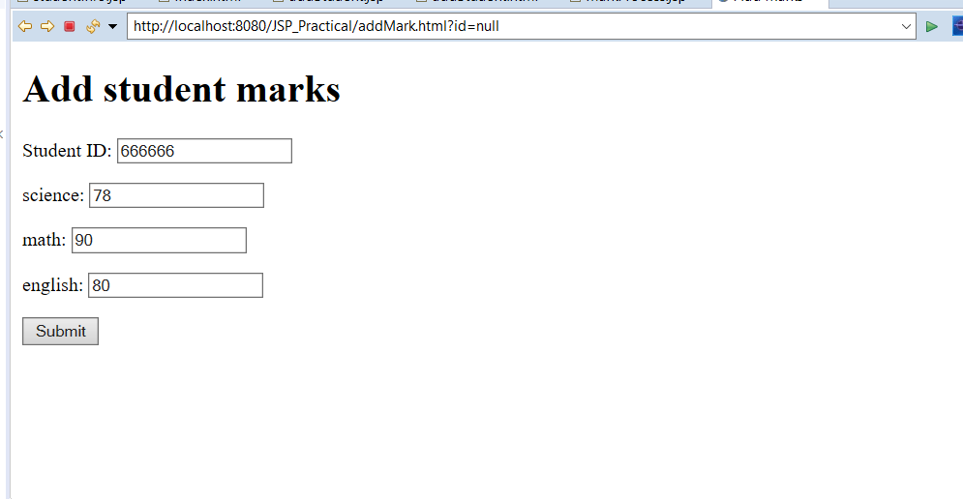

Student average marks page

In this page, students marks will be displayed with average marks for all the subjects

